Name: _______________________________________ Test Date: _________________
Study Guide – Cell Organelles and their Functions
Part 1: Identify Each Organelle from its Picture
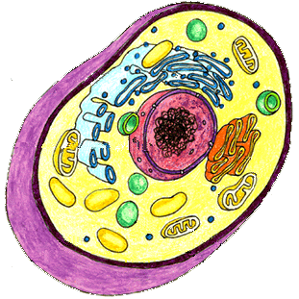
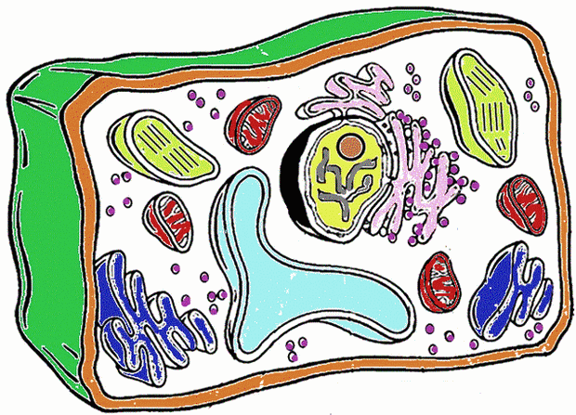

Part 2: Identify Each Organelle from Its Description:
1. The ___________________ is found in plants, and is a rigid structure that supports and protects the cell.
2. The ______________________ controls many functions of the cell, and contains DNA.
3. The _________________________ packages and distributes proteins out of the cell.
4. The _____________________ encloses, protects and controls movement in and out of the cell.
5. The ______________________ is a gel-like material that fills the cell and holds organelles in place.
6. The _________________________ is the main power source of the cell that produces energy from sugar.
7. The ________________________, found in cells, is where photosynthesis occurs, and light is converted to energy.
8. The ___________________________ transports materials, and breaks down toxic materials that could harm the cell.
9. The ______________________ is a large sac-like organelle that contains water and food inside the cell.
10. The ________________________ contains digestive enzymes that digest food and get rid of waste.
11. The ____________________ are small organelles that make protein, lipids and help break down toxins.
Part 3: Comparisons of Organelles
1. How do the Cell Wall and Cell Membrane work together in plant cells to:
Defend the cell:

2. How do the Nucleus and the Endoplasmic Reticulum (ER) work together in cells to:
Help the cell get energy:

3. How do Mitochondria and Chloroplasts work together in plant cells to:
Help the cell get energy:

4. How do the Golgi Apparatus and the Ribosomes work together in cells to:
Help the cell get energy:

