Genetics Study Guide
- Who is considered to be the “Father of Genetics?” ______________________________
- Explain what Mendel was trying to determine with his pea experiment?
_______________________________________________________________________________________________________________________________________________________________________________________________________________________________________________________________

Where are alleles located? And how are they represented in Punnett squares?

Define the following terms:

Alleles:

Dominant traits:

Recessive traits:

Homozygous:

Heterozygous:

Genotypes:

Phenotypes:

Determine if the genotypes are homozygous or heterozygous, and whether if they are expressing dominant or recessive trait.
- AA_________________ Bb __________________ gg ______________________

- QQ ________________ tt __________________ Tt ______________________

Determine the genotypes and phenotypes of the individuals below.
- Trait: eye color, A= green a= hazel. Parent 1: homozygous dominant, Parent 2: Heterozygous.

- Trait: hair line, E= straight e= widows peak. Parent 1: Homozygous dominant, Parent 2: Homozygous recessive.

- Trait: height, F= Tall f= short. Parent 1: Heterozygous, Parent 2: Heterozygous.

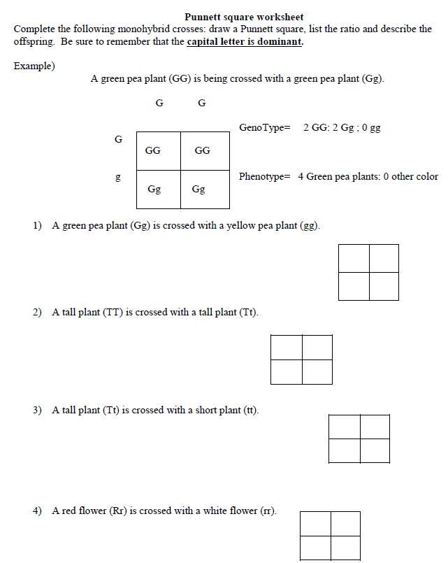

Use the below pedigree chart to answer the following questions about type of chin. The cleft chin gene controls whether a person has a cleft chin (e) or does not have a cleft chin. In this pedigree not having a cleft chin is dominant to having a cleft chin.
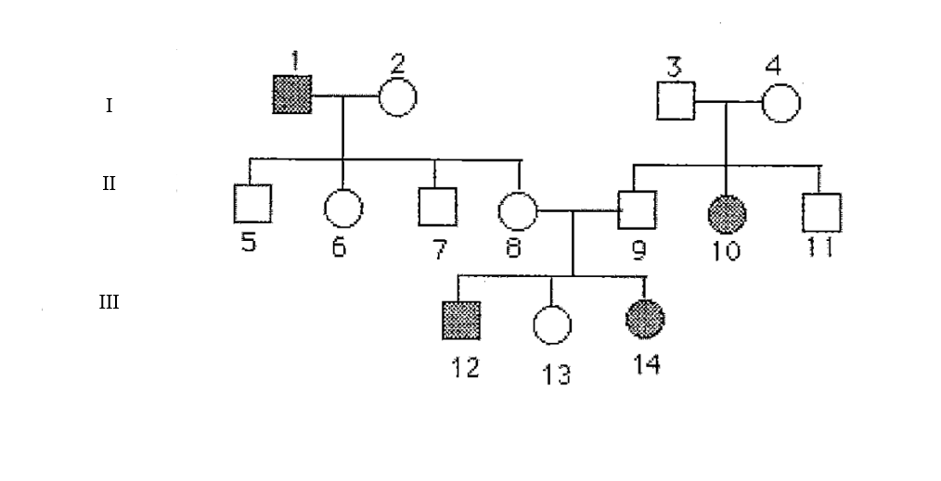
- What does the squares represent? What does the circles represent? What does the shaded in shapes represent?

- Label each genotype for each individual in the pedigree above their represented shape (1-14).

- Write down the pairs of numbers that represent a married couple and their generation.
(Ex: 15—16, II)

- Write the group of numbers that represent siblings.

- Write down the numbers that represent parents.

- What does the roman numerals represent?

- What is the relationship between 12, 13, and 14 with 2?

- What is the relationship between 12, 13, and 14 with 4?

- Is it possible for 8 and 9 to be homozygous? Explain your reasoning?

- How many individuals have a cleft chin? How many girls have a cleft chin? How many boys have a cleft chin?

