Genetics Study Guide Answer Key
- Who is considered to be the “Father of Genetics?” Gregor Mendel
- Explain what Mendel was trying to determine with his pea experiment?
How are traits determined when they are passed from parent to offspring.

Where are alleles located? And how are they represented in Punnett squares?
Alleles are located on chromosomes and they are represented by letters on the Punnett square.

Define the following terms:

Alleles: Different forms of a gene. (If a gene codes for hair color the allele would be the type hair color)

Dominant traits: Traits that cover up a recessive trait.

Recessive traits: Traits that are only expressed in the absence of a dominant trait.

Homozygous: Two of the same alleles (letters).

Heterozygous: Two different alleles (letters).

Genotypes: The possible combinations of alleles (letters).

Phenotypes: The physical traits that are expressed.

Determine if the genotypes are homozygous or heterozygous, and whether if they are expressing dominant or recessive trait.
- AA- Homozygous Dominant Bb - Heterozygous gg – Homozygous Recessive

- QQ – Homozygous Dominant tt – Homozygous Recessive Tt- Heterozygous

Determine the genotypes and phenotypes of the individuals below.
- Trait: eye color, A= green a= hazel. Parent 1: homozygous dominant, Parent 2: Heterozygous.

Parent 1: Genotype- AA, Phenotype- Green eyes
Parent 2: Genotype- Aa, Phenotype- Green eyes
- Trait: hair line, E= straight e= widows peak. Parent 1: Homozygous dominant, Parent 2: Homozygous recessive.

Parent 1: Genotype- EE, Phenotype- Straight hair line
Parent 2: Genotype- ee, Phenotype- Widows Peak
- Trait: height, F= Tall f= short. Parent 1: Heterozygous, Parent 2: Heterozygous.

Parent 1: Genotype- Ff, Phenotype- Tall
Parent 2: Genotype- Ff, Phenotype- Tall

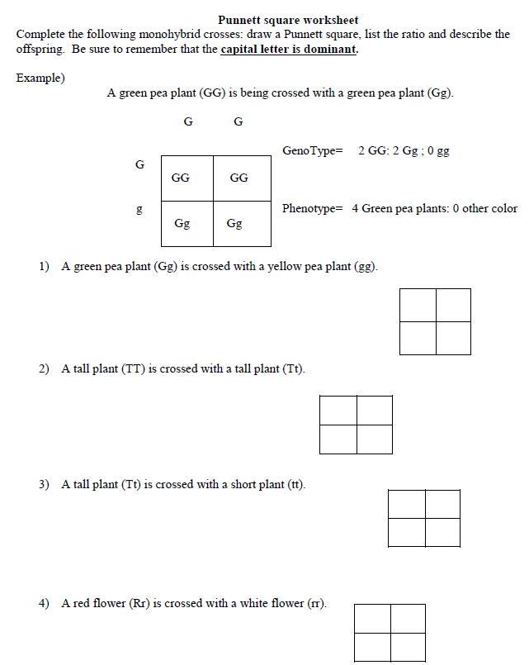
Genotype: 50% Rr, 50% rr ( 0 RR: 2 Rr: 0 rr)
Phenotype: 2 red flowers, 2 white flowers.
Genotype: 50% Tt, 50% tt (0 TT: 2 Tt: 2 tt)
Phenotype: 2 Tall plants, 2 short plants.

Genotype: 50% TT, 50% Tt (2 TT: 2 Tt: 0 tt)
Phenotype: 4 Tall plants: 0 short plants.

Genotype: 50% Gg, 50% gg (2 Gg: 2 gg: 0 GG)
Phenotype: 2 Green pea plants, 2 yellow pea plants.

Use the below pedigree chart to answer the following questions about type of chin. The cleft chin gene controls whether a person has a cleft chin (e) or does not have a cleft chin. In this pedigree not having a cleft chin is dominant to having a cleft chin.
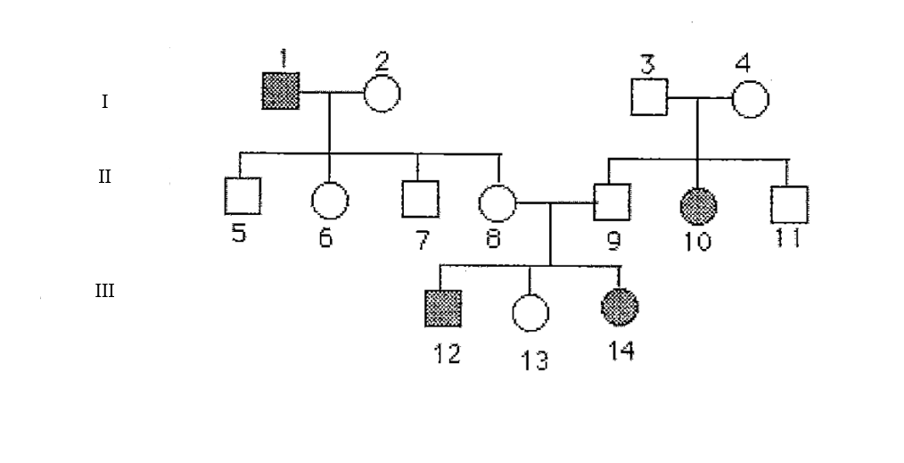

Ee
Ee
Ee
Ee
Ee
Ee
Ee
Ee
Ee
EE
ee
ee
ee
ee
- What does the squares represent? What does the circles represent? What does the shaded in shapes represent? Square represent males and circles represent female. The shaded shapes represent and individual with an expressed trait.

- Label each genotype for each individual in the pedigree above their represented shape (1-14).
Look at the pedigree for the genotypes.

- Write down the pairs of numbers that represent a married couple and their generation.
(Ex: 15—16, II)
(1—2, I) (3—4, I) (8—9, II)

- Write the group of numbers that represent siblings.
(II- 5,6,7,8) (II- 9,10,11) (III-12, 13, 14)

- Write down the numbers that represent parents.
(I-1 & 2) (I-3 &4) (II-8 & 9)

- What does the roman numerals represent?
Generations

- What is the relationship between 12, 13, and 14 with 2?
#2 is the maternal grandmother of 12, 13, and 14.

- What is the relationship between 12, 13, and 14 with 4?
#4 is the paternal grandmother of 12, 13, and 14.

- Is it possible for 8 and 9 to be homozygous? Explain your reasoning?
No, because they have a child that has a cleft chin (ee)

- How many individuals have a cleft chin? How many girls have a cleft chin? How many boys have a cleft chin? Four individuals have a cleft chin with two of them being girls, and two of them being boys.

