**S8CS3b**

|  |  |
| --- | --- |
| ______1. | Two teams compete in a tug-of-war contest during a school field day. Weights of team members are shown in the chart. Tonya analyzes this data to predict which team will win the competition.    Image  Which of the following correctly describes the data? |

|  |  |  |
| --- | --- | --- |
|  | **A.** | The mean weight of team B is 298 N greater than the mean weight of team A. |
|  | **B.** | The median weight of team B is 225 N and the median of team A is only 189 N. |
|  | **C.** | The mean weight of team B is 74.5 N greater than the mean weight of team A. |
|  | **D.** | The median weight of team B is 403 N and the median weight of team A is 367 N. |

**S8CS9a**

|  |
| --- |
| ______2. Pat set up four different jars with a burning candle in each jar. He put lids on jars **1, 2, and 3, as shown in the picture below.**    Image  The candle in jar 1 burned for 2 minutes after the lid was put on. The candle in jar 2 burned for 8 minutes. About how long did the candle in jar 3 burn after the lid was put on? |

|  |  |  |  |
| --- | --- | --- | --- |
| https://admin.achievementseries.com/images/shim.gif |  | **A.** | 1 minute |
| https://admin.achievementseries.com/images/shim.gif |  | **B.** | 4 minutes |
| https://admin.achievementseries.com/images/shim.gif |  | **C.** | 8 minutes |
| https://admin.achievementseries.com/images/shim.gif |  | **D.** | 10 minutes |

|  |
| --- |
|  |

|  |  |  |  |
| --- | --- | --- | --- |
|  |  |  |  |
|  |  |  |  |
|  |  |  |  |
|  |  |  |  |

**S8P1a**

|  |  |  |  |  |  |  |  |  |  |  |  |  |  |  |  |  |  |  |  |  |  |  |  |  |  |  |  |  |  |  |  |  |  |
| --- | --- | --- | --- | --- | --- | --- | --- | --- | --- | --- | --- | --- | --- | --- | --- | --- | --- | --- | --- | --- | --- | --- | --- | --- | --- | --- | --- | --- | --- | --- | --- | --- | --- |
| |  | | --- | | ______ 3. In the chemical formula for ammonia,WebEQ Image, what does the 3 represent? |  |  |  |  |  | | --- | --- | --- | --- | | https://admin.achievementseries.com/images/shim.gif |  | **A.** | The number of ammonia molecules that will bond together. | | https://admin.achievementseries.com/images/shim.gif |  | **B.** | The number of nitrogen atoms in each molecule of ammonia. | | https://admin.achievementseries.com/images/shim.gif |  | **C.** | The number of hydrogen atoms in each molecule of ammonia. | | https://admin.achievementseries.com/images/shim.gif |  | **D.** | The number of nitrogen and hydrogen atoms in each molecule of ammonia. |   ____ 10. ______ 4. An atom of carbon with the atomic number of 6 has how many protons?   |  |  |  |  | | --- | --- | --- | --- | | a. | 6. | c. | 12. | | b. | 18. | d. | 15. |   ____ 11. ______ 5. In order, what particles have a positive, neutral, and negative charge?   |  |  |  |  | | --- | --- | --- | --- | | a. | proton, electron, neutron | c. | neutron, proton, electron | | b. | proton, neutron, electron | d. | electron, proton, neutron |   **______ 6. Which of the following *best* describes an atom?**  **A** protons and electrons grouped together in a random pattern  **B** protons and electrons grouped together in an alternating pattern  **C** a core of protons and neutrons surrounded by electrons  **D** a core of electrons and neutrons surrounded by protons  **S8P1b**  _______7. A scientist chemically combines oxygen and hydrogen to form water. This combination illustrates that water is |
|  |

|  |  |  |  |
| --- | --- | --- | --- |
| https://admin.achievementseries.com/images/shim.gif |  | **A.** | an atom |
| https://admin.achievementseries.com/images/shim.gif |  | **B.** | an element |
| https://admin.achievementseries.com/images/shim.gif |  | **C.** | a mixture |
| https://admin.achievementseries.com/images/shim.gif |  | **D.** | a compound |

**_____** 8. When magnesium (Mg) metal is burned in the presence of oxygen (O), magnesium oxide (MgO) is produced. The properties of magnesium oxide are different than the individual properties of magnesium and oxygen because magnesium oxide is

**A.** a solution.

**B.** a mixture.

**C.** a compound.

**D.** an element.

|  |
| --- |
| ______9. Several centuries ago, men called alchemists tried to transform common metals into gold. Even though they tried many different chemical and physical methods, they never succeeded because |

|  |  |  |  |
| --- | --- | --- | --- |
| https://admin.achievementseries.com/images/shim.gif |  | **A.** | they could not heat common metals to extremely high temperatures. |
| https://admin.achievementseries.com/images/shim.gif |  | **B.** | the common metals they worked with were not pure. |
| https://admin.achievementseries.com/images/shim.gif |  | **C.** | they did not add the correct material to the common metal. |
| https://admin.achievementseries.com/images/shim.gif |  | **D.** | they did not have the ability change elements to other elements by physical or chemical means |
| |  | | --- | | _____ 16  ________ 20_____10. If two poisonous elements are combined chemically, which of the following will be true of the resulting compound?  A. The compound will be more poisonous than the gases.  B. The compound will be as poisonous as the gases.  C. The compound may or may not be poisonous.  D. The compound will not be poisonous.  _____2_____11. In the boxes below, solid circles represent the atoms of one element, while the hollow circles represent the atoms of a second element. Of the four boxes shown above, which is **NOT** a pure substance? D |   **S8P1c**  _______ 12. Particles in a certain material vibrate in place so the material keeps its shape and volume. What is the physical state of this material? | | | | | |

|  |  |  |  |
| --- | --- | --- | --- |
| https://admin.achievementseries.com/images/shim.gif |  | **A.** | Gas |
| https://admin.achievementseries.com/images/shim.gif |  | **B.** | Solid |
| https://admin.achievementseries.com/images/shim.gif |  | **C.** | Liquid |
| https://admin.achievementseries.com/images/shim.gif |  | **D.** | Plasma |

______13. The circles in the bottles represent the same particles of matter. Which pattern of particles represents a gas in a bottle?

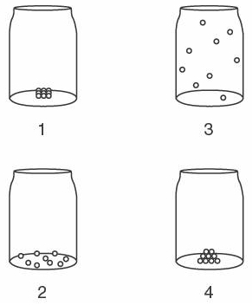

1. **1**
2. **2**
3. **3**
4. **4**

______14. How do the particles of water that evaporate from an open container differ from the particles that remain?

|  |  |
| --- | --- |
| a. | The evaporated particles only have more speed. |
| b. | The evaporated particles have greater order. |
| c. | The evaporated particles only have higher energy. |
| d. | The evaporated particles have more speed and higher energy. |

_____ 15. All of the liquid from a test tube is poured into an empty beaker, as shown in the diagram below.

Compared to the liquid that **was** in the test tube, the liquid in the beaker now has

(**A**) a different volume, but the same shape

(**B**) a different volume and a different shape

(**C**) the same volume, but a different shape

(**D**) the same volume and the same shape

_____ 16. Which of the following would **BEST** demonstrate a plasma?

a. lightning

b. steam

c. light

d. electricity

**S8P1d**

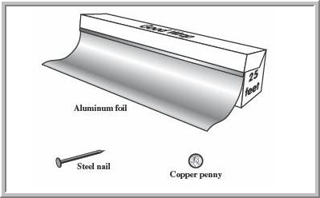______17. The picture below shows three objects that can be classified in the same group.

Which of the following statements is **true** for all **three** of these objects?

A. They are metals.

B. They rust rapidly.

C. They weigh the same.

D. They are the same color.

_____ 18. The diagram below shows what occurred when a can of diet soda and a can of regular soda were dropped into a container of water.

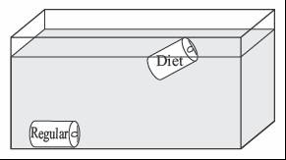

The can of regular soda sank to the bottom of the container, but the can of diet soda floated. Which of the following statements best explains this observation?

|  |  |  |  |
| --- | --- | --- | --- |
| https://admin.achievementseries.com/images/shim.gif |  | **A.** | The can of regular soda is less dense than the can of diet soda. |
| https://admin.achievementseries.com/images/shim.gif |  | **B.** | The can of regular soda is denser than the can of diet soda. |
| https://admin.achievementseries.com/images/shim.gif |  | **C.** | The can of regular soda has a larger volume than the can of diet soda. |
| https://admin.achievementseries.com/images/shim.gif |  | **D.** | The can of regular soda has a smaller volume than the can of diet soda |

_____ 19. Which class of elements *best* conducts electricity?

**A** metals

**B** nonmetals

**C** semimetals

**D**  gases

______ 20. The following table shows properties of four different sample materials. One of these materials is cork, a type of wood that floats in water.

|  |  |  |
| --- | --- | --- |
| Physical Properties Sample Number | Mass | Volume |
| 1 | 89 g | 10 mL |
| 2 | 26 g | 10 mL |
| 3 | 24 g | 100 mL |
| 4 | 160 g | 100 mL |

Given that the density of water is 1 g/mL, which of the samples is *most* likely cork? (Remember: density = mass ÷ volume)

**A** 1

**B** 2

**C** 3

**D** 4

____ 21. Which of the following is a chemical property of matter?

|  |  |  |  |
| --- | --- | --- | --- |
| a. | solubility | c. | density |
| b. | volume | d. | reactivity |

**S8P1e**

______ 22. After fishing in the ocean, a student left his fishing gear in the sun to dry. Later, he noticed that small white crystals had formed on the rod, reel, and fishing line. Which of these is the best explanation of what occurred?

A. The water evaporated from the fishing gear, and sand was attracted to it.

B. The fish that were caught left scales on the fishing gear.

C. The salt in the ocean water reacted with the fishing gear and caused it to rust.

D. The water evaporated from the fishing gear, and salt from the ocean was left behind.

______ 23. The melting of wax is a physical change, yet the burning of wax is a chemical change. What is the essential difference between the physical change and chemical change of wax in a burning candle?

A. Melted wax is a different phase of matter than solid wax.

B. A higher temperature is needed to burn wax than to melt wax.

C. Melted wax can be separated into other substances, while solid wax cannot.

D. The burning of wax forms new compounds, while the melting of wax does not.

______ 24. Which of the following is an example of a chemical reaction?

A. A piece of wax melting and forming a liquid

B. A piece of chalk making white marks on a chalkboard

C. Bubbles of gas forming when a seashell is placed in vinegar

D. Powder dissolving in hot water to make hot chocolate

**S8P1f**

_______ 25. A student adds 5 grams of vinegar to 7 grams of baking soda in a closed system. Then he watches the chemical reaction that occurs. Which of these predicts the mass of the materials in the container after the reaction is complete?

A 00 grams

B 02 grams

C 12 grams

D 35 grams

|  |  |
| --- | --- |
| Refer to the periodic table to answer questions 26-27  _____ 17.  Image  Which o | |
| _____ 26. Which statement correctly describes the elements cobalt (Co), nickel (Ni), and silver (Ag)? |

|  |  |  |  |
| --- | --- | --- | --- |
| https://admin.achievementseries.com/images/shim.gif |  | **A.** | They are gases. |
| https://admin.achievementseries.com/images/shim.gif |  | **B.** | They conduct heat. |
| https://admin.achievementseries.com/images/shim.gif |  | **C.** | They are nonmetals. |
| https://admin.achievementseries.com/images/shim.gif |  | **D.** | They all have the same density. |

_____27. Which two elements are most alike?

a. Li & Na b. Li & Be

c. B & Si d. B & C

____28. Vertical columns on the periodic table that share similar properties are called

|  |  |  |  |
| --- | --- | --- | --- |
| a. | periods. | c. | elements. |
| b. | groups or families. | d. | properties |

____ 29. The periodic table is arranged by

|  |  |  |  |
| --- | --- | --- | --- |
| a. | state | c. | atomic number |
| b. | reactivity | d. | atomic mass. |

**S8P1f**

|  |
| --- |
| _____30 . The picture below shows a demonstration of water changing from the liquid phase to the gas phase as it boils in a beaker.    Image  Which of the following statements explains why this demonstration **cannot** be used to prove that matter is conserved during a change of phase? |

|  |  |  |  |
| --- | --- | --- | --- |
| https://admin.achievementseries.com/images/shim.gif |  | **A.** | The change of phase is incomplete. |
| https://admin.achievementseries.com/images/shim.gif |  | **B.** | Water is changing both phase and temperature. |
| https://admin.achievementseries.com/images/shim.gif |  | **C.** | Water in the gas phase is lighter than liquid water. |
| https://admin.achievementseries.com/images/shim.gif |  | **D.** | The change of phase is taking place in an open system. |

|  |
| --- |
|  |

______ 31. When heated, oxygen reacts with copper to form copper oxide.

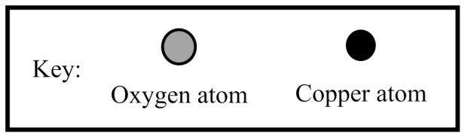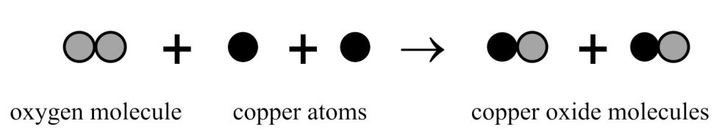

If this reaction occurs in a sealed container, will the mass of the container and everything in it increase, decrease, or stay the same and why?

1. The mass will stay the same because the number of each kind of atom stays the same.
2. The mass will decrease because two substances combine to form one substance.
3. The mass will increase because a new kind of molecule is formed.
4. More information is needed to tell if the mass will change

**S8P3b**

_____32. A car's motion is described by the diagram below.

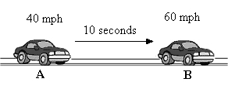

Which statement correctly describes the car's motion from point A to point B?

A. The car is accelerating and velocity increases.

B. The car is decelerating and velocity increases.

C. The car is decelerating and velocity decreases.

D. The car is accelerating and velocity is constant.

|  |
| --- |
| ______33. Taya walked 0.24 **km** to mail a letter. It took her exactly 2 **minutes** to arrive at the mailbox. (Remember KHDbdcm)    Image   What was Taya’s average speed? |

|  |  |  |  |
| --- | --- | --- | --- |
| https://admin.achievementseries.com/images/shim.gif |  | **A.** | 2 **meters/second** |
| https://admin.achievementseries.com/images/shim.gif |  | **B.** | 12 **meters/second** |
| https://admin.achievementseries.com/images/shim.gif |  | **C.** | 0.4 **kilometers/hour** |
| https://admin.achievementseries.com/images/shim.gif |  | **D.** | 0.12 **kilometers/second** |
| _____ 34. Janelle kicks a ball across a field. She records the distance and time the ball traveled. Image      If the ball does NOT decelerate, how far will the ball travel in 12 seconds? | | | | | |

|  |  |  |  |
| --- | --- | --- | --- |
| https://admin.achievementseries.com/images/shim.gif |  | **A.** | 25 feet |
| https://admin.achievementseries.com/images/shim.gif |  | **B.** | 30 feet |
| https://admin.achievementseries.com/images/shim.gif |  | **C.** | 35 feet |
| https://admin.achievementseries.com/images/shim.gif |  | **D.** | 40 feet |

|  |  |  |  |  |  |  |  |  |  |  |  |  |  |  |  |  |  |  |  |  |  |  |  |  |  |  |  |  |  |  |  |  |  |  |  |  |  |  |  |  |  |  |  |  |  |  |  |  |  |  |  |  |  |  |  |  |  |
| --- | --- | --- | --- | --- | --- | --- | --- | --- | --- | --- | --- | --- | --- | --- | --- | --- | --- | --- | --- | --- | --- | --- | --- | --- | --- | --- | --- | --- | --- | --- | --- | --- | --- | --- | --- | --- | --- | --- | --- | --- | --- | --- | --- | --- | --- | --- | --- | --- | --- | --- | --- | --- | --- | --- | --- | --- | --- |
| ____35. The graph below shows the motion of an object traveling in a straight line.    Image [Show Explanations](JavaScript:toggleItemExplanation();)   |  |  |  |  |  |  |  |  |  |  |  |  |  |  | | --- | --- | --- | --- | --- | --- | --- | --- | --- | --- | --- | --- | --- | --- | | |  | | --- | |  | | **A** | **The object is not accelerating** |  | | **B** | **The object's velocity is decreasing over time.** |  | | **C** | **The object is accelerating over time.** |  | | **D** | **The object is slowly decelerating.** |  |     **S8P3b** | | 36. Ricardo drops a marble onto another marble that is placed on a table.    Image    Which statement **best** describes some of the forces involved? | | |  |  |  |  |  |  | | --- | --- | --- | --- | --- | | https://admin.achievementseries.com/images/shim.gif |  | **A.** | Before the collision, the forces acting on marble 1 are balanced. | | | https://admin.achievementseries.com/images/shim.gif |  | **B.** | Before the collision, the forces acting on marble 2 are balanced. | | | https://admin.achievementseries.com/images/shim.gif |  | **C.** | During the collision, the forces of gravity and inertia are balanced. | | | https://admin.achievementseries.com/images/shim.gif |  | **D.** | Before the collision, the forces of friction and gravity acting on marble 1 are balanced. | | | 37. A ball rolls on the floor from point A to point B.    Image      What is true about the frictional force acting on the ball as it is rolling? | | | |  |  |  |  |  | | --- | --- | --- | --- | | https://admin.achievementseries.com/images/shim.gif |  | **A.** | It is equal to the applied force. | | https://admin.achievementseries.com/images/shim.gif |  | **B.** | It is less than the applied force. | | https://admin.achievementseries.com/images/shim.gif |  | **C.** | It is greater than the applied force. | | https://admin.achievementseries.com/images/shim.gif |  | **D.** | It is acting in the same direction of the applied force. |   *____ 38. Use the image below to answer the question that follows.*  Image  Two boys wearing in-line skates are standing on a smooth surface with the palms of their hands touching and their arms bent, as shown above. If Boy X pushes by straightening his arms out while Boy Y holds his arms in the original position, what is the motion of the two boys? |

|  |  |  |  |  |  |
| --- | --- | --- | --- | --- | --- |
| https://admin.achievementseries.com/images/shim.gif | |  | **A.** | Boy X and Boy Y both move backward. | |
| https://admin.achievementseries.com/images/shim.gif | |  | **B.** | The motion depends on how hard Boy X pushes. | |
| https://admin.achievementseries.com/images/shim.gif | |  | **C.** | Boy X does not move and Boy Y moves backward. | |
| https://admin.achievementseries.com/images/shim.gif | |  | **D.** | Boy Y does not move and Boy X moves backward. | |
|  | | | |
| |  | | --- | | _____ 39. If a solid object is taken from Earth far into space, which of the following measurements of the object will change MOST? |  |  |  |  |  | | --- | --- | --- | --- | | https://admin.achievementseries.com/images/shim.gif |  | **A.** | Mass | | https://admin.achievementseries.com/images/shim.gif |  | **B.** | Weight | | https://admin.achievementseries.com/images/shim.gif |  | **C.** | Volume | | https://admin.achievementseries.com/images/shim.gif |  | **D.** | Density |   **______** 40.A car manufacturer reduces the mass of a car by 250 kg. If the new design is otherwise identical to the old design, how will the new car compare to the old car?    **A** It will have a greater gravitational attraction to the road.  **B** It will require more fuel to operate.  **C** It will need less force to move.  **D** It will release more gas emissions.  ____ 41. Four forces are acting on a box as shown below    This box will move  A. down and to the left  B. down and to the right  C. up and to the left  D. up and the right  **S8P5c**  ______ 42. Gravity is the force between two objects that pulls them together. All of the objects below are made of the same material. Which two objects will have the LEAST gravitational pull between them? | | | | | | | |
|  | | | | | | | |

|  |  |  |  |
| --- | --- | --- | --- |
| https://admin.achievementseries.com/images/shim.gif |  | **A.** | Image |
| https://admin.achievementseries.com/images/shim.gif |  | **B.** | Image |
| https://admin.achievementseries.com/images/shim.gif |  | **C.** | Image |
| https://admin.achievementseries.com/images/shim.gif |  | **D.** | Image |

______ 43. Over the early part of Earth’s history, the planet grew in size and mass. Which graph BEST represents Earth’s gravity during that time of growth? B

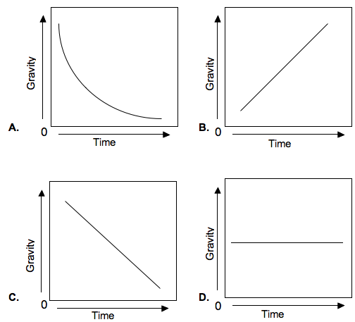

|  |
| --- |
| 44. The space shuttle uses booster rockets for its launch, but does not need them for the rest of its journey. This is because the booster rockets |

|  |  |  |  |
| --- | --- | --- | --- |
| https://admin.achievementseries.com/images/shim.gif |  | **A.** | Direct the shuttle onto its correct orbital path |
| https://admin.achievementseries.com/images/shim.gif |  | **B.** | Allow the shuttle to overcome the pull of gravity |
| https://admin.achievementseries.com/images/shim.gif |  | **C.** | Reduce the amount of fuel needed for the launch |
| https://admin.achievementseries.com/images/shim.gif |  | **D.** | Protect the shuttle from damage during the launch. |