Force ​ and​ ​ Motion​ ​ Unit​ ​ 2​​ ​Study ​ Guide​

Velocity ​ and​ ​ Acceleration​
1.​ ​What​ ​is​ ​the​ ​difference​ ​between​ ​velocity​ ​and​ ​acceleration?

2.​ ​Identify​ ​whether​ ​the​ ​following​ ​statements​ ​describe​ ​a​ ​change​ ​in​ ​acceleration.​ ​Explain​ ​your​ ​response​ ​for​ each​.
a.​ ​A​ ​car ​ ​stopped​ ​at​ ​a​ ​stop​ ​sign.
b.​ ​A​ ​boat​ ​traveling​ ​east​ ​at​ ​10​ ​knots.
c.​ ​An ​ ​airplane​ ​traveling​ ​north ​​600​ ​miles​ ​per​ ​hour.
d.​ ​A​ ​person​ ​running​ ​at​ ​5​ ​meters/second​ ​along​ ​a​ ​curving​ ​path.

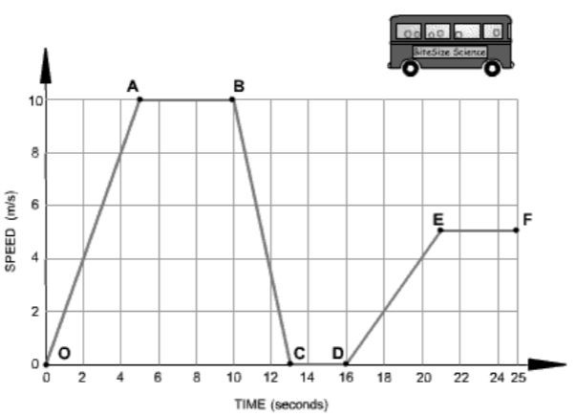
The​ ​graph ​ below​ ​ shows​ ​ how​ ​ ​the ​ speed​ ​ of​ ​​a​ ​bus ​ changes​ ​ during​ ​ part​ ​ of​ a​ ​journey.​ ​Use​ ​this​ ​graph​ ​to​ ​answer​ ​questions​ ​3-5.

3.​ ​In​ ​Segment​ ​B-C,​ ​the​ ​bus​ ​is​ ​_______ ​Why?

4.​ ​In​ ​Segment​ ​C-D,​ ​the​ ​bus​ ​is​ ​______ ​Why?

5.​ ​Which​ ​Segment(s)​ ​is​ ​accelerating?​ ​How​ ​do​ ​you​ ​know?

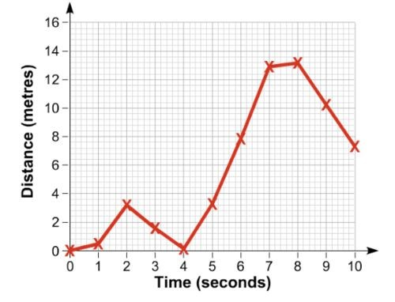
6.​ ​The​ ​graph​ ​shows​ ​the​ ​motion​ ​of​ ​a​ ​runner.​ ​Use​ ​the​ ​graph ​ to​ ​ the​ right​ ​to​ ​answer​ ​the​ ​questions​ ​below.
- During​ ​which​ ​interval​ ​does​ ​the ​runner​ ​ achieve​ ​ its​ greatest​ ​speed?​ ​How​ do​ ​ ​you​ ​know?

- ​ Describe ​the​ ​runner’s​ ​motion​ between​​ 2​​ ​and​ ​4​ ​seconds?

- What​ ​is​ ​the​ ​runner’s​ speed​ ​at ​second ​6?​ ​SHOW​ ​YOUR
WORK.

7.​ ​Joe​ ​drives​ ​at​ ​a​ ​speed​ ​of​ ​30​ ​m/s​ ​in​ ​3​ ​minutes.​ ​What​ ​is​ ​the​ distance​ ​that​ ​Joe​ ​travels?​ ​SHOW​ ​YOUR​ ​WORK​ ​(formula, plug​ ​in​ ​numbers,​ ​answer,​ ​unit)
D
T S
8.​ ​What​ ​is​ ​required​ ​to​ ​determine​ ​speed?

9.​ ​What​ ​is​ ​the​ speed​ ​of​ ​a​ ​biker​ ​that​ ​travels​ ​50​ ​m​ ​in​ ​4​ ​seconds?​ ​SHOW​ ​YOUR​ ​WORK​ ​(formula,​ ​plug​ ​in,​ ​answer,​ ​unit).

10.​ ​What​ ​is​ ​the​ ​unit​ ​for​ ​the​ ​following:​ ​mass,​ ​weight,​ ​force,​ ​speed/velocity,​ ​acceleration,​ ​distance,​ ​and​ ​time?

11.​ ​The​ ​characteristics​ ​of​ ​motion​ ​are​ ​speed,​ acceleration,​ ​ direction,​ and​ position.​​ ​Which​ ​of​ ​the​ ​these​ ​can​ ​change​ without​ changing​ ​the​ ​velocity?​ ​Hint:​ ​Use​ ​an​ ​example​ ​velocity​ ​and​ ​compare​ ​each

Balanced ​ and​ ​ Unbalanced​ ​ Forces​ : ​ Gravity,​ ​ Friction,​ ​ ​Applied ​ ​force, ​ Air​ ​ resistance​
12.​ ​Name​ ​whether​ ​the​ ​following​ ​is​ ​a​ ​balanced​ ​or​ ​unbalanced​ ​force.​ ​Explain​ ​why.
a. A​ ​book​ ​at​ ​rest.
- A​ ​train​ ​moving​ ​at​ ​a​ ​constant​ ​velocity
- A​ ​student​ ​running​ ​down​ ​the​ ​hall.

13.​ ​(a)​ ​Indicate​ ​if​ ​it​ is​ ​ a​ ​ balanced​ ​ or​ ​ unbalanced​ ​ force.​ ​ (​ b) ​ Write​ ​ the​ ​ ​direction ​ ​of ​ its​ ​ movement,​ ​​or​ ​no ​ ​movement. ​ ​( c) ​ ​Write the​ ​net​ ​force​ ​of​ ​each.​ ​(BE​ ​SURE​ ​TO​ ​INCLUDE​ ​THE​ ​UNIT)

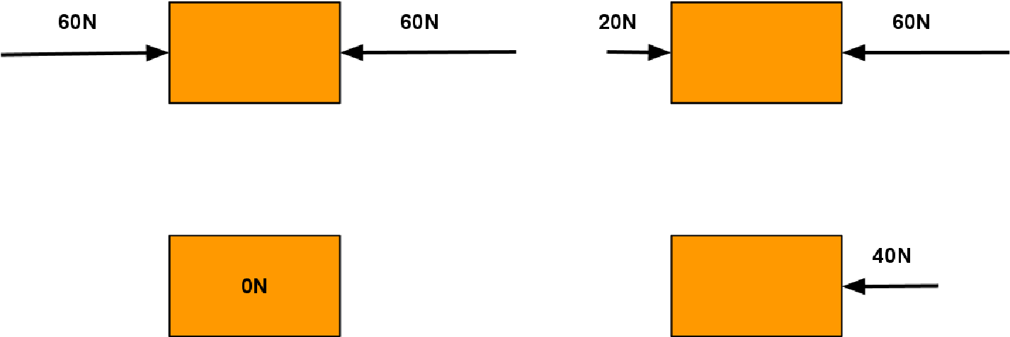

14.​ ​Jenna​ ​and​ ​Mark​ ​went​ ice​ ​ skating.​ ​ With​ ​ ​both ​ hands​ ​ ​touching ​ ​and both​ ​ ​arms ​​bent,​ they​ ​stood​ in​ ​the ​ middle​ ​of​ ​the ​rink. Jenna​ ​pushes​ ​by​ ​straightening​ ​her​ ​arms​ ​out,​ ​while​ ​Mark​ ​kept​ ​his​ ​position.​ ​What​ ​is​ ​the​ ​motion​ ​of​ ​both​ ​friends?
- Jenna​ moves​ ​ backwards​ ​ only​ C. ​ Both​ move​ ​ backwards​
- Mark​ ​moves​ ​backwards​ ​only D.​ ​Both​ ​remain​ ​in​ ​the ​​same​ ​position

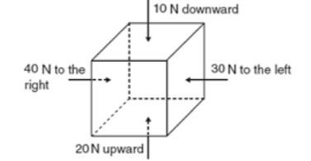
15.​ ​Look​ ​at​ ​the​ ​diagram​ ​of​ ​the​ ​box​ ​to​ ​the​ ​right.​ ​In​ ​which​ ​direction​ ​will​ ​the box​ ​increase​ ​in​ ​speed?​ ​Explain​ ​your​ ​answer.

16.​ ​A​ ​force​ ​(F1)​ ​is​ ​required​ ​to​ ​push​ ​a​ ​15kg​ ​container​ across​ ​ a​ ​ carpeted​ ​ ​floor.​ ​A ​ force​ ​ (​ F2) ​ is​ ​ required​ ​​to​ ​push ​ the​same​ 15kg​ ​container​ ​across​ ​the​ ​ice​ ​at​ ​a​ ​rink.​ ​What​ ​is​ ​typically​ ​true​ ​about​ ​the​ ​F1​ ​force​ ​in​ ​comparison​ ​to​ ​the​ ​F2​ ​force?
17.​ ​How​ ​does​ ​the​ ​distance​ ​between​ ​two​ ​objects​ ​and​ ​their​ ​mass​ ​affect​ ​gravitational​ ​attraction​ ​(force)​ ​between​ ​the​ ​two objects?​ ​Give​ ​an​ ​example.

18.​ ​Sally​ ​pulled​ ​the​ ​car​ ​keys​ ​to​ ​the​ ​Mercedes ​ from​ ​ her​ ​ ​sister​ ​20​ ​N​ ​to​ ​the​ ​left. ​​Her ​ sister​ pulled​ ​ at​ ​ 15​ ​​N​ ​to ​ the​ ​ right.​ ​ What​ was​ ​the​ ​net​ ​force​ ​of​ ​the​ ​keys?​ ​Draw​ ​a​ ​force​ ​diagram​ ​to​ ​represent​ ​the​ ​situation​ ​above.

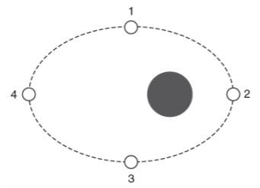
19.​ ​The​ ​diagram​ ​to​ the​ ​ right​ ​ shows​​ a​​ ​moon ​ revolving​ ​ around​ ​ a​ ​ planet​ ​ in​ ​ an​ ​ orbit.​ ​ At​ which​ ​location​ ​is​ ​the​ ​gravitational ​ pull​ ​ ​between ​​the ​​moon​ ​and​ ​the​ ​planet​ ​the weakest?​ ​Explain​ ​your​ ​answer.

20.​ ​A​ ​hammer​ ​and​ ​a​ ​feather​ ​are​ ​dropped​ ​from​ ​the ​ same​ ​ height​ ​ at​ ​ the​ ​ same​ ​ time.​ There​ ​is​ ​no​ ​air​ ​resistance.​ ​Which​ ​object​ ​will​ ​hit​ ​the​ ​ground​ ​first?
- Hammer C.​ ​Object ​ with​ ​ the​ ​ ​larger ​ ​mass
- Feather D. ​ ​They​ ​will​ ​land ​at​​ ​the​ ​same​ ​time

21.​ ​Your​ ​mortal​ ​enemy​ ​pushes​ ​your​ ​Ipad​ ​off​ ​your​ ​desk.​ ​What​ ​force​ ​is​ ​acting​ ​on​ ​your​ ​Ipad​ ​while​ ​it​ ​is​ ​in​ ​the​ ​air?
- Only​ ​the​ ​force ​ of​ ​ gravity​ C. ​ Both​​ the​​ force​ of​​ gravity​ ​ and​ your​ ​ mortal​ ​ enemy​
- Only​ ​the​ ​force​ ​of​ ​your ​​mortal​ ​enemy D.​ ​Neither​ ​the​ ​force​ ​of​ ​gravity​ or​​ ​your​ mortal​​ ​enemy

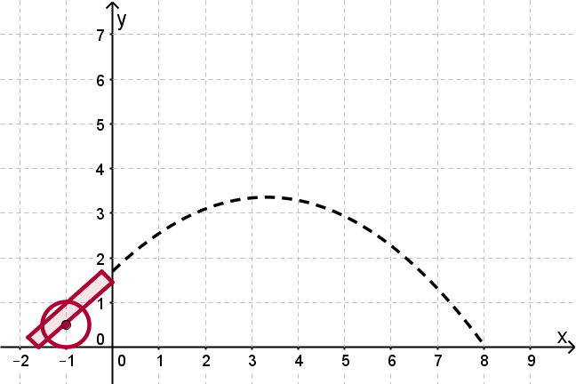
22.​ ​What​ ​forces​ ​is​ ​causing​ ​the​ ​cannonball​ ​to​ ​follow​ ​a​ ​curved​ ​path?

23.​ ​What​ ​are​ ​some​ ​ways​ ​reducing​ ​friction​ ​would​ ​help​ ​in​ ​a​ ​sport​ ​like​ ​surfing?​ ​What​ ​about​ ​with​ ​ice​ ​skating?

24.​ ​Ms.​ ​Lee​ ​is​ ​pushing​ ​her​ ​dog​ ​Lyla​ ​towards ​ the​ ​ bathroom​ for her​ ​weekly​ ​bath.​ ​The​ ​directions​ ​of​ ​the​ ​arrows​ show​ ​ ​the directions​ ​of​ ​the ​ forces,​ ​ and​ ​ the​ ​ ​lengths ​ of​​ the​ ​ arrows​ represent​ ​the​ ​strengths ​ of​ ​ the​ ​ forces.​ ​ Which​ ​ of​ ​ the​ ​ following​ statements​ ​are​ ​true?
- Lyla​ ​will​ ​move ​ at​ ​ ​a ​ ​constant ​ speed​
- Lyla​ ​will​ ​stop ​ moving​
- Lyla​ ​will​ ​decelerate
- Lyla​ ​will​ ​accelerate

Reference ​ Point​
25.​ ​You​ ​are​ ​riding​ ​on​ ​a​ ​bus​ ​going​ ​40​ ​miles/hour.​ ​Are​ ​you​ ​moving?
- No,​ ​not ​ if​ ​ the​ ​ reference​ ​​point ​ ​is​ the​ ​ bus​
- Yes,​ ​if​ ​the​ ​reference​ ​point ​ is​ ​ someone​ ​ standing​ ​ ​on ​ the​ ​ sidewalk​
- No,​ ​not​ ​if​ ​the​ ​reference​ point​ ​​is​ ​the​ ​bus​ ​driver
- All​ ​of​ ​the​ ​above
26.​ ​A​ ​mother​ ​is​ ​riding​ ​a​ ​bike,​ ​pulling​ ​her​ ​children​ ​in​ ​a​ ​cart​ ​behind​ ​the​ ​bike.​ ​Is​ ​the​ ​mother​ ​moving​ ​relative​ ​to​ ​the​ ​car*bike*?
- Yes
- No
27.​ ​Bart​ ​is​ ​riding​ ​his​ ​skateboard​ ​7​ ​m/s​ ​towards​ ​school​ ​from​ ​home.​ ​He​ ​gets​ ​to​ ​school​ ​in​ ​about​ ​15​ ​minutes.​ ​What​ ​is​ ​the reference​ ​point?
- Skateboard
- Bart
- School
- Home

Mass ​ v.​ ​ Weight​
28.​ ​What​ ​is​ ​the​ ​difference​ ​between​ ​mass​ ​and​ ​weight?​ ​Name​ ​at​ ​least​ ​3​ ​ways​ ​they​ ​differ.

29.​ ​Which​ ​has​ ​the​ ​most​ ​gravity?
A. ​ ​B.​ ​
​

​
_
​

​
​ ​C.​ ​​ ​_________________________________
​

​
___________________

Newton’s ​ Laws​ ​ of​ ​ Motion​
30.​ ​On​ ​a​ ​frictionless​ ​surface,​ ​how​ ​does​ ​the​ ​increase​ ​in​ ​an​ ​object’s​ ​mass​ ​affect​ ​its​ ​acceleration?
31.​ ​Define​ ​inertia.

32.​ ​Identify​ ​which​ ​of​ ​the​ ​following​ ​objects​ ​has​ ​the​ ​most​ ​inertia:​ ​3​ ​g​ ​gumball;​ ​2​ ​kg​ ​tennis​ ​ball;​ ​2​ ​g​ ​ping​ ​pong​ ​ball;​ ​5​ ​kg basketball.​ ​Explain​ ​your​ ​answer.
.
33.​ ​Mark​ ​is​ ​a​ ​NASCAR​ ​driver.​ ​The​ ​mass​ ​of​ ​his ​ car​ ​ were​ ​ to​ ​ increase​ ​ by​ ​​30% ​​and​ ​he​ ​is​ ​unhappy​ ​about​ this.​ ​​Why?​ ​How ​​is this​ ​relate​ ​to​ ​Newton’s​ ​2nd​ ​law​ ​of​ ​motion?
34.​ ​The​ ​normal​ ​force​ ​on​ ​a​ ​book​ ​at​ ​rest​ ​is​ ​20​ ​N.​ ​What​ ​is​ ​the​ ​reaction​ ​force​ ​equal​ ​to?
- The​ ​force​ ​is​ ​greater ​ than​ its​ ​ weight​ C. ​ More​ ​ information​ ​ is​​ needed​
- The​ ​force​ ​is​ ​equal​ ​to​ ​the​ ​weight​ of​ ​​the​ ​book D.​ ​The​ ​force​ ​is ​​undeterminable
*Weight is the force of gravity on an object with mass.
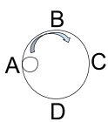
35.​ ​Steve​ ​is​ ​rolling​ ​a​ ​marble​ ​around​ ​in​ ​a​ ​cup.​ ​Draw​ ​the​ ​direction​ ​the​ ​marble​ ​will​ ​go​ ​if​ ​it was​ ​released​ ​at​ ​D.

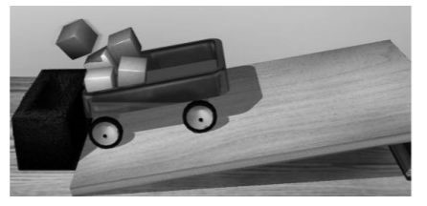
36.​ ​The​ ​diagram​ ​to​ ​the ​ ​right ​ ​shows ​ ​a ​ cart​​ ​full​ of​ ​ blocks​ ​ coming​ ​ to​ a​ ​sudden​ ​stop.​ ​Explain​ ​what​ ​happens​ ​to​ ​the​ ​blocks​ ​in​ ​the​ ​cart.

37.​ ​Which​ ​of​ ​the​ ​following​ ​would​ ​have​ ​the​ ​MOST​ ​acceleration?
a.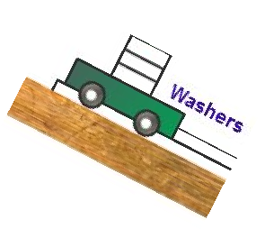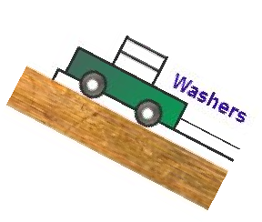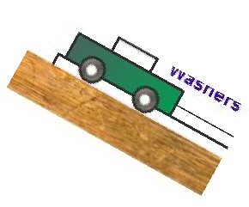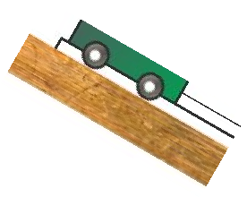
b.
c.
d.

*Less mass, more acceleration*

