Force ​ and​ ​ Motion​ ​ Unit​ ​ 2​​ ​Study ​ Guide​

Velocity ​ and​ ​ Acceleration​
1.​ ​What​ ​is​ ​the​ ​difference​ ​between​ ​velocity​ ​and​ ​acceleration?
Velocity is speed with a particular direction and acceleration is the rate speed changes over time.
2.​ ​Identify​ ​whether​ ​the​ ​following​ ​statements​ ​describe​ ​a​ ​change​ ​in​ ​acceleration.​ ​Explain​ ​your​ ​response​ ​for​ each​.
a.​ ​A​ ​car ​ ​stopped​ ​at​ ​a​ ​stop​ ​sign. Zero acceleration (at rest)
b.​ ​A​ ​boat​ ​traveling​ ​east​ ​at​ ​10​ ​knots. Zero acceleration (constant velocity)
c.​ ​An ​ ​airplane​ ​traveling​ ​north ​​600​ ​miles​ ​per​ ​hour. Zero acceleration (constant velocity)
d.​ ​A​ ​person​ ​running​ ​at​ ​5​ ​meters/second​ ​along​ ​a​ ​curving​ ​path. Acceleration (change in direction)

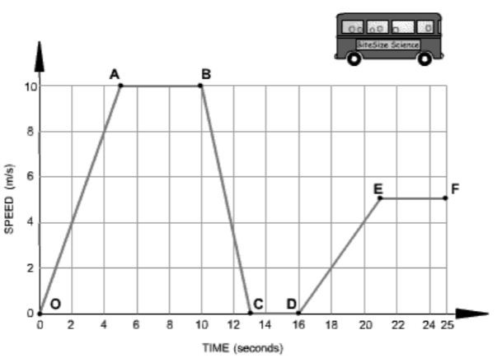
The​ ​graph ​ below​ ​ shows​ ​ how​ ​ ​the ​ speed​ ​ of​ ​​a​ ​bus ​ changes​ ​ during​ ​ part​ ​ of​ a​ ​journey.​ ​Use​ ​this​ ​graph​ ​to​ ​answer​ ​questions​ ​3-5.

3.​ ​In​ ​Segment​ ​B-C,​ ​the​ ​bus​ ​is​ ​_______decelerating_________​ ​Why?
The speed is decreasing over time.
4.​ ​In​ ​Segment​ ​C-D,​ ​the​ ​bus​ ​is​ ​______at rest__________​ ​Why?
The speed is not changing from zero over time.
5.​ ​Which​ ​Segment(s)​ ​is​ ​accelerating?​ ​How​ ​do​ ​you​ ​know?
Segment O-A and D-E. They both show speed increasing over time.

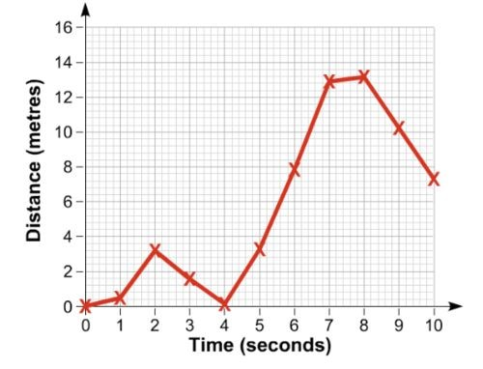
6.​ ​The​ ​graph​ ​shows​ ​the​ ​motion​ ​of​ ​a​ ​runner.​ ​Use​ ​the​ ​graph ​ to​ ​ the​ right​ ​to​ ​answer​ ​the​ ​questions​ ​below.
- During​ ​which​ ​interval​ ​does​ ​the ​runner​ ​ achieve​ ​ its​ greatest​ ​speed?​ ​How​ do​ ​ ​you​ ​know?
From 5 seconds to 7 seconds. Distance over time (13-3=10m/2s= 5 m/s. Also it has the greatest slope.

- ​ Describe​ ​ ​the​ ​runner’s​ ​motion​ between​​ 2​​ ​and​ ​4​ ​minutes? (meant to say seconds, not minutes)
Coming back home

- What​ ​is​ ​the​ ​runner’s​ speed​ ​at ​​minute​ ​6?​ ​SHOW​ ​YOUR
WORK. (meant to say seconds, not minutes)
8 m/6s = 1.33 m/s
7.​ ​Joe​ ​drives​ ​at​ ​a​ ​speed​ ​of​ ​30​ ​m/s​ ​in​ ​3​ ​minutes.​ ​What​ ​is​ ​the​ distance​ ​that​ ​Joe​ ​travels?​ ​SHOW​ ​YOUR​ ​WORK​ ​(formula, plug​ ​in​ ​numbers,​ ​answer,​ ​unit)
D
T S D = T x S 3 mins x 30 m/s = 90 meters
8.​ ​What​ ​is​ ​required​ ​to​ ​determine​ ​speed? Distance and time
9.​ ​What​ ​is​ ​the​ speed​ ​of​ ​a​ ​biker​ ​that​ ​travels​ ​50​ ​m​ ​in​ ​4​ ​seconds?​ ​SHOW​ ​YOUR​ ​WORK​ ​(formula,​ ​plug​ ​in,​ ​answer,​ ​unit).
Distance/Time = Speed 50 m/4 s = 12.5 m/s
10.​ ​What​ ​is​ ​the​ ​unit​ ​for​ ​the​ ​following:​ ​mass,​ ​weight,​ ​force,​ ​speed/velocity,​ ​acceleration,​ ​distance,​ ​and​ ​time?
Mass (grams) Weight (Newtons) Force (Newtons) Speed/velocity (m/s) acceleration (m/s²) distance (meters) time (seconds, minutes, hours)
11.​ ​The​ ​characteristics​ ​of​ ​motion​ ​are​ ​speed,​ acceleration,​ ​ direction,​ ​ and​ ​ position.​​ ​Which​ ​of​ ​the​ ​these​ ​can​ ​change​ without​ changing​ ​the​ ​velocity?​ ​Hint:​ ​Use​ ​an​ ​example​ ​velocity​ ​and​ ​compare​ ​each
Position can change without changing the velocity. I can start my position at 2 meters or 200 meters and my velocity can still end up the same.

Balanced ​ and​ ​ Unbalanced​ ​ Forces​ : ​ Gravity,​ ​ Friction,​ ​ ​Applied ​ ​force, ​ Air​ ​ resistance​
12.​ ​Name​ ​whether​ ​the​ ​following​ ​is​ ​a​ ​balanced​ ​or​ ​unbalanced​ ​force.​ ​Explain​ ​why.
a. A​ ​book​ ​at​ ​rest. Balanced: zero acceleration, no motion, zero net force
- A​ ​train​ ​moving​ ​at​ ​a​ ​constant​ ​velocity. Balanced: zero acceleration, constant velocity, zero net force
- A​ ​student​ ​running​ ​down​ ​the​ ​hall. Unbalanced: accelerating (speeding up), net force>0

13.​ ​(a)​ ​Indicate​ ​if​ ​it​ is​ ​ a​ ​ balanced​ ​ or​ ​ unbalanced​ ​ force.​ ​ (​ b) ​ Write​ ​ the​ ​ ​direction ​ ​of ​ its​ ​ movement,​ ​​or​ ​no ​ ​movement. ​ ​( c) ​ ​Write the​ ​net​ ​force​ ​of​ ​each.​ ​(BE​ ​SURE​ ​TO​ ​INCLUDE​ ​THE​ ​UNIT)

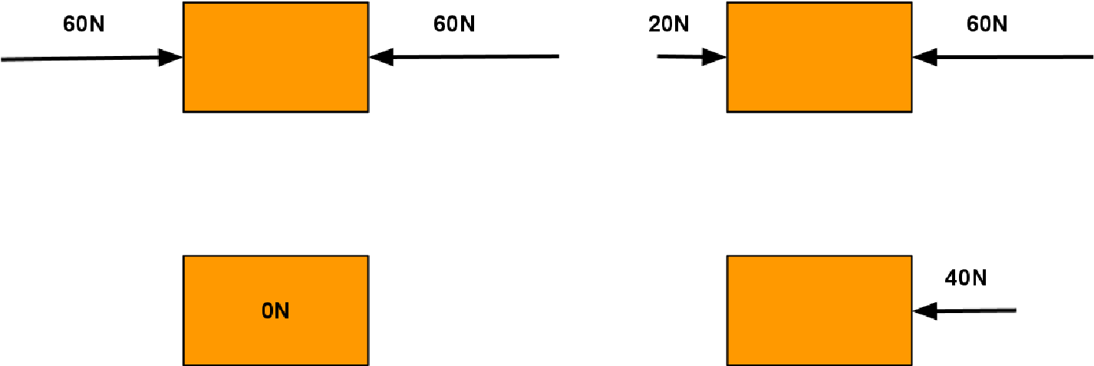

Balanced, no movement, Net force = 0 Unbalanced, Left, Net force = 40 N left

Balanced force, no movement, Net force = 0 Unbalanced, left, Net force = 40 N left

14.​ ​Jenna​ ​and​ ​Mark​ ​went​ ice​ ​ skating.​ ​ With​ ​ ​both ​ hands​ ​ ​touching ​ ​and ​ both​ ​ ​arms ​​bent,​ they​ ​stood​ ​​in​ ​the ​ middle​ ​ ​of​ ​the ​ ​rink.
Jenna​ ​pushes​ ​by​ ​straightening​ ​her​ ​arms​ ​out,​ ​while​ ​Mark​ ​kept​ ​his​ ​position.​ ​What​ ​is​ ​the​ ​motion​ ​of​ ​both​ ​friends?
- Jenna​ moves​ ​ backwards​ ​ only​ C. ​ Both​ ​ move​ ​ backwards​
- Mark​ ​moves​ ​backwards​ ​only D.​ ​Both​ ​remain​ ​in​ ​the ​​same​ ​position

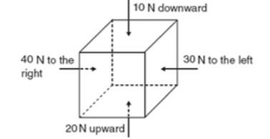
15.​ ​Look​ ​at​ ​the​ ​diagram​ ​of​ ​the​ ​box​ ​to​ ​the​ ​right.​ ​In​ ​which​ ​direction​ ​will​ ​the box​ ​increase​ ​in​ ​speed?​ ​Explain​ ​your​ ​answer.
Northeast because if forces are greater upward and to the right, then it will end up going diagonally up and to the right or northeast direction.

16.​ ​A​ ​force​ ​(F1)​ ​is​ ​required​ ​to​ ​push​ ​a​ ​15kg​ ​container​ across​ ​ a​ ​ carpeted​ ​ ​floor.​ ​A ​ force​ ​ (​ F2) ​ is​ ​ required​ ​​to​ ​push ​ the​same​ 15kg​ ​container​ ​across​ ​the​ ​ice​ ​at​ ​a​ ​rink.​ ​What​ ​is​ ​typically​ ​true​ ​about​ ​the​ ​F1​ ​force​ ​in​ ​comparison​ ​to​ ​the​ ​F2​ ​force?
F1 has more force of friction acting against the applied force to push the container across the carpet than F2 as this has little to no frictional force acting against the container.
17.​ ​How​ ​does​ ​the​ ​distance​ ​between​ ​two​ ​objects​ ​and​ ​their​ ​mass​ ​affect​ ​gravitational​ ​attraction​ ​(force)​ ​between​ ​the​ ​two objects?​ ​Give​ ​an​ ​example.
Closer they are, greater the gravitational attraction
Greater the mass, greater the gravitational attraction
18.​ ​Sally​ ​pulled​ ​the​ ​car​ ​keys​ ​to​ ​the​ ​Mercedes ​ from​ ​ her​ ​ ​sister​ ​20​ ​N​ ​to​ ​the​ ​left. ​​Her ​ sister​ ​ pulled​ ​ at​ ​ 15​ ​​N​ ​to ​ the​ ​ right.​ ​ What​ was​ ​the​ ​net​ ​force​ ​of​ ​the​ ​keys?​ ​Draw​ ​a​ ​force​ ​diagram​ ​to​ ​represent​ ​the​ ​situation​ ​above.
5 N left

20 N 15 N

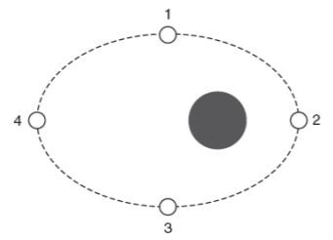
19.​ ​The​ ​diagram​ ​to​ the​ ​ right​ ​ shows​​ a​​ ​moon ​ revolving​ ​ around​ ​ a​ ​ planet​ ​ in​ ​ an​ ​ orbit.​ ​ At​ which​ ​location​ ​is​ ​the​ ​gravitational ​ pull​ ​ ​between ​​the ​​moon​ ​and​ ​the​ ​planet​ ​the weakest?​ ​Explain​ ​your​ ​answer.
Weakest at position 4 because there is greater distance between the planet and moon.

20.​ ​A​ ​hammer​ ​and​ ​a​ ​feather​ ​are​ ​dropped​ ​from​ ​the ​ same​ ​ height​ ​ at​ ​ the​ ​ same​ ​ time.​ There​ ​is​ ​no​ ​air​ ​resistance.​ ​Which​ ​object​ ​will​ ​hit​ ​the​ ​ground​ ​first?
- Hammer C.​ ​Object ​ with​ ​ the​ ​ ​larger ​ ​mass
- Feather D. ​ ​They​ ​will​ ​land ​at​​ ​the​ ​same​ ​time

21.​ ​Your​ ​mortal​ ​enemy​ ​pushes​ ​your​ ​Ipad​ ​off​ ​your​ ​desk.​ ​What​ ​force​ ​is​ ​acting​ ​on​ ​your​ ​Ipad​ ​while​ ​it​ ​is​ ​in​ ​the​ ​air?
- Only​ ​the​ ​force ​ of​ ​ gravity​ C. ​ Both​​ the​ ​ force​ ​ of​​ gravity​ ​ and​ ​ your​ ​ mortal​ ​ enemy​
- Only​ ​the​ ​force​ ​of​ ​your ​​mortal​ ​enemy D.​ ​Neither​ ​the​ ​force​ ​of​ ​gravity​ or​​ ​your​ mortal​​ ​enemy
*Remember to pick the best answer. The answer would have been better if it said force of gravity and air resistance.
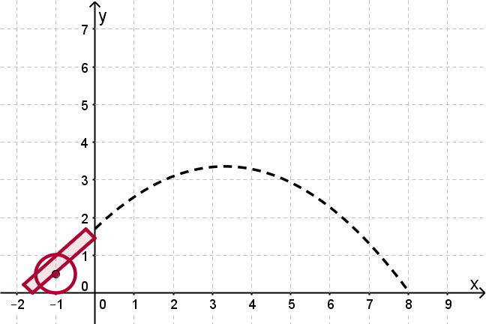
22.​ ​What​ ​forces​ ​is​ ​causing​ ​the​ ​cannonball​ ​to​ ​follow​ ​a​ ​curved​ ​path?
Gravity

23.​ ​What​ ​are​ ​some​ ​ways​ ​reducing​ ​friction​ ​would​ ​help​ ​in​ ​a​ ​sport​ ​like​ ​surfing?​ ​What​ ​about​ ​with​ ​ice​ ​skating?
Reducing friction with surfing would help with smoother strides. Ice skating would also help with moving faster.

24.​ ​Ms.​ ​Lee​ ​is​ ​pushing​ ​her​ ​dog​ ​Lyla​ ​towards ​ the​ ​ bathroom​ for her​ ​weekly​ ​bath.​ ​The​ ​directions​ ​of​ ​the​ ​arrows​ show​ ​ ​the directions​ ​of​ ​the ​ forces,​ ​ and​ ​ the​ ​ ​lengths ​ of​​ the​ ​ arrows​ represent​ ​the​ ​strengths ​ of​ ​ the​ ​ forces.​ ​ Which​ ​ of​ ​ the​ ​ following​ statements​ ​are​ ​true?
- Lyla​ ​will​ ​move ​ at​ ​ ​a ​ ​constant ​ speed​
- Lyla​ ​will​ ​stop ​ moving​
- Lyla​ ​will​ ​decelerate
- Lyla​ ​will​ ​accelerate

Reference ​ Point​
25.​ ​You​ ​are​ ​riding​ ​on​ ​a​ ​bus​ ​going​ ​40​ ​miles/hour.​ ​Are​ ​you​ ​moving?
- No,​ ​not ​ if​ ​ the​ ​ reference​ ​​point ​ ​is​ the​ ​ bus​
- Yes,​ ​if​ ​the​ ​reference​ ​point ​ is​ ​ someone​ ​ standing​ ​ ​on ​ the​ ​ sidewalk​
- No,​ ​not​ ​if​ ​the​ ​reference​ point​ ​​is​ ​the​ ​bus​ ​driver
- All​ ​of​ ​the​ ​above
26.​ ​A​ ​mother​ ​is​ ​riding​ ​a​ ​bike,​ ​pulling​ ​her​ ​children​ ​in​ ​a​ ​cart​ ​behind​ ​the​ ​bike.​ ​Is​ ​the​ ​mother​ ​moving​ ​relative​ ​to​ ​the​ ​car*bike*?
- Yes
- No
27.​ ​Bart​ ​is​ ​riding​ ​his​ ​skateboard​ ​7​ ​m/s​ ​towards​ ​school​ ​from​ ​home.​ ​He​ ​gets​ ​to​ ​school​ ​in​ ​about​ ​15​ ​minutes.​ ​What​ ​is​ ​the reference​ ​point?
- Skateboard
- Bart
- School
- Home

Mass ​ v.​ ​ Weight​
28.​ ​What​ ​is​ ​the​ ​difference​ ​between​ ​mass​ ​and​ ​weight?​ ​Name​ ​at​ ​least​ ​3​ ​ways​ ​they​ ​differ.
- Mass stays the same, and weight can change based on which planet you are on.
- Mass is measured in grams, and weight is measured in Newtons.
- Mass uses balances, and weight use scales to measure

29.​ ​Which​ ​has​ ​the​ ​most​ ​gravity?
A. ​ ​B.​ ​
​

​
_
​

​
​ ​C.​ ​​ ​_________________________________
​

​
___________________

Newton’s ​ Laws​ ​ of​ ​ Motion​
30.​ ​On​ ​a​ ​frictionless​ ​surface,​ ​how​ ​does​ ​the​ ​increase​ ​in​ ​an​ ​object’s​ ​mass​ ​affect​ ​its​ ​acceleration? More mass means less acceleration.
31.​ ​Define​ ​inertia.
Inertia is the TENDENCY of an object to remain at rest or remain in motion. Inertia will depend on mass. More mass, more inertia.
32.​ ​Identify​ ​which​ ​of​ ​the​ ​following​ ​objects​ ​has​ ​the​ ​most​ ​inertia:​ ​3​ ​g​ ​gumball;​ ​2​ ​kg​ ​tennis​ ​ball;​ ​2​ ​g​ ​ping​ ​pong​ ​ball;​ ​5​ ​kg basketball.​ ​Explain​ ​your​ ​answer.
5 kg basketball because it has more mass.
33.​ ​Mark​ ​is​ ​a​ ​NASCAR​ ​driver.​ ​The​ ​mass​ ​of​ ​his ​ car​ ​ were​ ​ to​ ​ increase​ ​ by​ ​​30% ​​and​ ​he​ ​is​ ​unhappy​ ​about​ this.​ ​​Why?​ ​How ​​is this​ ​relate​ ​to​ ​Newton’s​ ​2nd​ ​law​ ​of​ ​motion?
Newton’s 2nd law shows us that lighter mass will accelerate better, so increasing the mass by 30% will make the car accelerate less strongly unless more force is applied.
34.​ ​The​ ​normal​ ​force​ ​on​ ​a​ ​book​ ​at​ ​rest​ ​is​ ​20​ ​N.​ ​What​ ​is​ ​the​ ​reaction​ ​force​ ​equal​ ​to?
- The​ ​force​ ​is​ ​greater ​ than​ ​ its​ ​ weight​ C. ​ More​ ​ information​ ​ is​​ needed​
- The​ ​force​ ​is​ ​equal​ ​to​ ​the​ ​weight​ of​ ​​the​ ​book D.​ ​The​ ​force​ ​is ​​undeterminable
*Weight is the force of gravity on an object with mass.
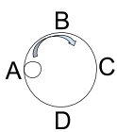
35.​ ​Steve​ ​is​ ​rolling​ ​a​ ​marble​ ​around​ ​in​ ​a​ ​cup.​ ​Draw​ ​the​ ​direction​ ​the​ ​marble​ ​will​ ​go​ ​if​ ​it was​ ​released​ ​at​ ​D.

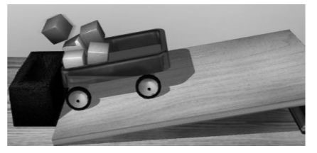
36.​ ​The​ ​diagram​ ​to​ ​the ​ ​right ​ ​shows ​ ​a ​ cart​​ ​full​ of​ ​ blocks​ ​ coming​ ​ to​ a​ ​sudden​ ​stop.​ ​Explain​ ​what​ ​happens​ ​to​ ​the​ ​blocks​ ​in​ ​the​ ​cart.
The blocks have a tendency to keep moving forward in a straight line, so it will fly forward.

37.​ ​Which​ ​of​ ​the​ ​following​ ​would​ ​have​ ​the​ ​MOST​ ​acceleration?
a.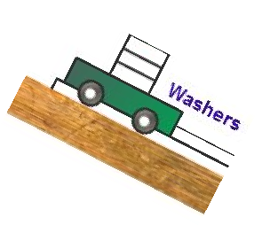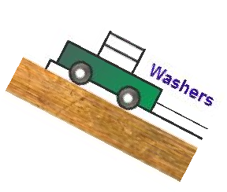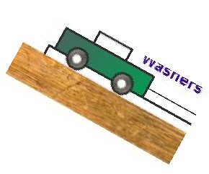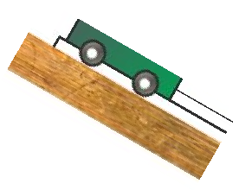
b.
c.
d.

*Less mass, more acceleration*

