Name: ______________________

Cellular Processes Study Guide

What is the difference between osmosis & diffusion?
____________________________________________________________________________________________________________________________________________________________________________________

What is a concentration gradient & how do molecules naturally move in one?
____________________________________________________________________________________________________________________________________________________________________________________

What is the difference between PASSIVE & ACTIVE transport?

__________________________________________________________________________________________

Endocytosis moves particles _________ the cell.

Exocytosis moves particles _____ ___ the cell.

List two examples of active transport. ________________________ & _________________________

List two examples of passive transport. ___________________________ & ____________________________

Please draw a diagram below that illustrates what is happening during Endocytosis & Exocytosis

Stage 1 | Stage 2 | Stage 3

Label the following diagrams as ISOTONIC, HYPERTONIC, or HYPOTONIC
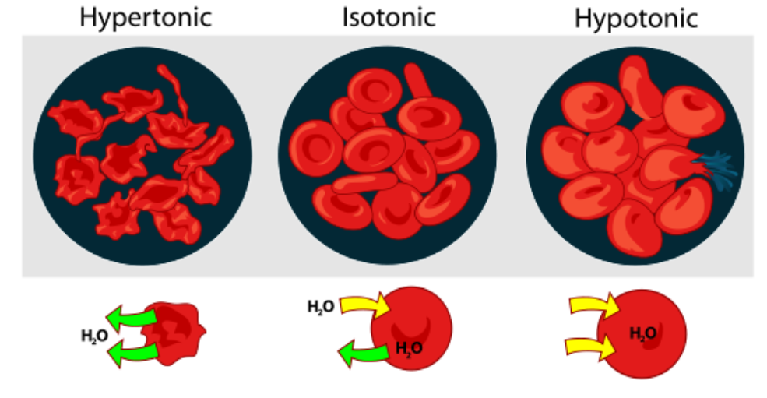
____________________ _____________________ ____________________
If you sprinkle sugar on fresh strawberries, juice will appear on the strawberries within a few minutes. Explain why this happens (in terms of osmosis & diffusion).
__________________________________________________________________________________________
____________________________________________________________________________________________________________________________________________________________________________________

Cell membranes are semi-permeable. What does that mean & why is this important?
____________________________________________________________________________________________________________________________________________________________________________________

Why can gargling with salt water when you have a sore throat relieve some of the pain?
______________________________________________________________________________________________________________________________________________________________________________________________________________________________________________________________________________

Please explain the diagram below and how it can help you remember the different types of transport.
Label what each side represents and why. Also label examples of each type and the direction of the concentration gradient.
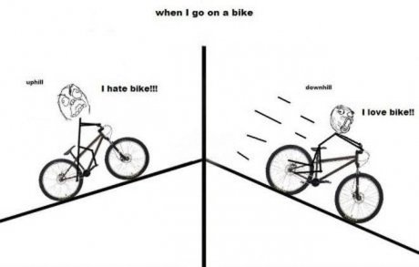

How do photosynthesis and cellular respirations compare to each other?

__________________________________________________________________________________________

Where does the energy for photosynthesis come from?

__________________________________________________________________________________________

What plant pigment is involved in photosynthesis? ________________________________________________

How does your body get the energy it needs from the food you eat (what process allows cellular energy to be made)?

__________________________________________________________________________________________

In what organelle of a plant cell does photosynthesis take place? ______________________________________

What are the products of photosynthesis?

__________________________________________________________________________________________

Write the equation for photosynthesis?

__________________________________________________________________________________________

What is the overall reaction (formula) for cell respiration?

__________________________________________________________________________________________

Write the equation for cellular respiration.

__________________________________________________________________________________________

In what organelle of a cell does cellular respiration take place? _______________________________________

What are the reactants of cellular respiration?

__________________________________________________________________________________________

